“Thank you so much for the great opportunity to become a part of the WNIT community and support the station. We’ve love it – and it loves us back!”
Dennis V.
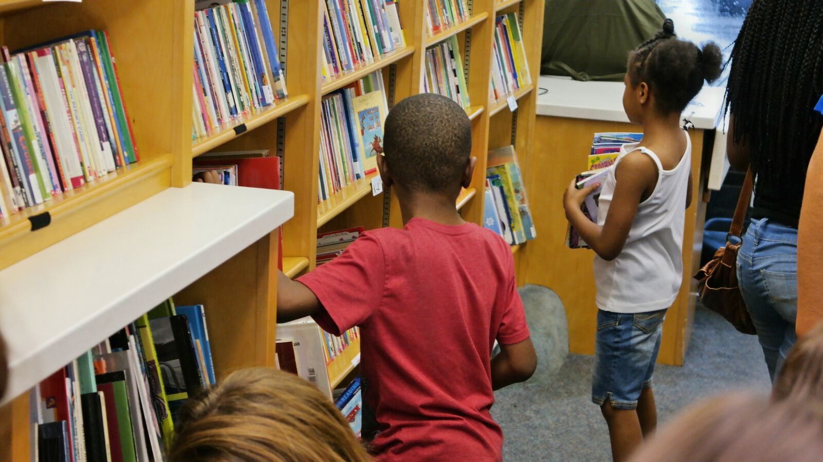
Mission Statement: WNIT is a trusted, community owned public media source that is dedicated to inspire, inform, educate, entertain and unify the communities we serve.
2019 LOCAL CONTENT AND SERVICE
REPORT TO THE COMMUNITY
2019 KEY
SERVICES
LOCAL VALUE

LOCAL IMPACT

WNIT’s local services had deep impact in the Michiana area.
- Website had 244,473 unique visitors and 329,668 page views.
- Partnerships with over 90 local organizations throughout Michiana
- Produced “Live From Notre Dame” at the University of Notre Dame’s DeBartolo Performing Arts Center.
- Produced,” Helping Hands for Hospice Foundation” and a series of videos for the local Family & Children’s Center and the Quilt Gardens, which help to educate people in our viewing areas on the people, places and events in and around the community.
WNIT is a valuable part of the Michiana community.
Our Vision is to foster enlightenment in our community, anytime, every time and everywhere.
Our Promise is to uphold and foster our most valued asset, the public trust. We will actively embrace this promise by adhering to these values and principles:
- We will provide communication content that inspires, educates and entertains.
- We will champion and provide free access to the multi-media world.
- We will manage a fiscally responsible organization without seeking profit.
In 2019, WNIT provided these key local services:
- Continued to air Experience Michiana in addition to 5 other local productions - Dinner & a Book, Economic Outlook, Outdoor Elements, Politically Speaking and EducationCounts_Michiana.
- Produced 3 series documentaries: Our Town: Berrien Springs & Legends of Michiana: Joe Kernan & Pat Moody
- Partnered with St. Joseph County Public Library for One Book, One Michiana.
- WNIT Kids Club continued to show strong membership growth sending the membership over 500. WNIT Kids Day in the Park saw almost 700 individuals in attendance.
- Maintained PBS initiative NEXT AVENUE in Michiana to reach age 50+ population
- Participated in “Success by Six” Early Childhood Education Summit
- Launched “PBS Kids 24/7 Channel on WNIT”

WNIT continues to maintain an active and involved presence throughout the Michiana community. During the year, WNIT maintained the PBS initiative NEXT AVENUE in Michiana. NEXT AVENUE is a major PBS system website designed to reach America’s booming 50+ populations as they plan for and literally define a new life stage. NEXT AVENUE provides articles, blogs, slideshows and videos that address a wide range of financial, caregiving, health and lifestyle topics for older adults.
In April, WNIT again partnered with the St. Joseph County Public Library as part of its ONE BOOK, ONE MICHIANA event. The title of this year’s book was “The Hitchhiker’s Guide to the Galaxy” by Douglas Adams, and it was discussed on an April episode of our popular DINNER & A BOOK with host, Gail Martin and her guest, Doug Farmwald.
We have several opportunities throughout the year for WNIT members to win tickets to events at local venues. These events included Bubble Gum Pop Tour, Mannheim Steamroller Christmas, the Texas Tenors and various area symphonies to name a few. In all, WNIT maintains about 90 active partnerships with organizations throughout Michiana.
WNIT maintained an active presence in the community as media sponsors for the the Lubeznik Center’s Art Festival in Michigan City, Warsaw “Lakes Festival,” Michiana Bike/Walk for Hospice, Valparaiso Art Barn student art classes and Montessori Academy Schools annual “Fall Frolic.”

The WNIT Kids Club participated in the WNIT Kids Day in the Park at St. Patrick’s Park, with almost 700 parents and kids in attendance. WNIT staff members also attended the Elkhart County Early Childhood Education “Success by Six” Summit in Goshen to learn the latest in early childhood development training and share PBS Learning Media resources with those in attendance.
WNIT’s Center for Public Media remained a hub of activity throughout the year. The Community Room played host to some 5000 community members in over 250 meetings and lunches.
WNIT’s Planner remains a staple of membership benefits, with over 6,800 copies per issue. The full-color, 32-36 page magazine is printed bi-monthly and contains complete listings for all three channels (34.1, 34.2 and 34.3), program highlights, and features about our Membership, Development, Production, Kids Club and Directors’ Circle.
WNIT also maintains an active and energetic presence in social media. Our web site has continued to be an invaluable resource for our community, reaching 244,473 unique visitors and 329,668 page views during the fiscal year. Facebook has blossomed to over 4,500 followers and the WNIT Instagram page has gained over 150 followers.

In addition, each month we send out approximately 7,500 electronic newsletters to bring our viewers up-to-the-minute announcements, scheduling and updates. To compliment the electronic newsletters, WNIT also sends out various electronic ticket offers for area plays, sporting events, screening, etc. These offers are usually sold out in minutes, and gives those signed up to receive our newsletters and offers, a chance to attend some of the area events they wouldn’t normally have a chance to obtain tickets for.

2019 LOCAL CONTENT AND SERVICE REPORT
IN THE COMMUNITY
In March EXPERIENCE MICHIANA a daily, magazine style program, featuring hosts, Rick Hummer and Kelly Morgan, returned for its seventh season on the air at WNIT. Rather than a daily show as it has been since its inception, EXPERIENCE MICHIANA now airs weekly on Thursdays with repeats on Fridays and Saturdays. It features all the good things to see and do in the region and has something for viewers of all ages. There are segments reviewing the latest DVD releases, nature and outdoor exploration, and places to go to have a great EXPERIENCE. We visit museums, art galleries, and community theaters to find out what’s happening behind the scenes. Over 6,000 guests have appeared on EXPERIENCE MICHIANA. It was a hit from the beginning and forms a wonderful complement to our five other locally-produced weekly programs--ECONOMIC OUTLOOK, DINNER & A BOOK, OUTDOOR ELEMENTS, EDUCATIONCOUNTS_MICHIANA and POLITICALLY SPEAKING.
An increasingly important segment of WNIT’s funding is generated by Work for Hire—products such as training tapes or web videos—that are created and produced by our Production staff. During the current year, we produced work for the Family & Children’s Center Hospice and Quilt Gardens .
We also continued and developed new partnerships to produce the following more extensive projects:
- The University of Notre Dame’s DeBartolo Performing Arts Center and WNIT Public Television presented LIVE FROM NOTRE DAME……performances in dance, theater and music from the campus of the University of Notre Dame. These special presentations gave viewers at home a chance to witness the breathtaking beauty, creativity and skill that is brought to the stages of the DeBartolo Performing Arts Center.

In June, WNIT launched the all-new “PBS Kids 24/7 Channel on WNIT,” a dedicated channel for children's programming. This free service ensures the high-quality content of PBS KIDS programming is available on weekends, at primetime, and during other out-of-school times throughout the week, when children are most likely to tune in and need quality educational television.
2019 LOCAL CONTENT AND SERVICE REPORT
IN THE COMMUNITY
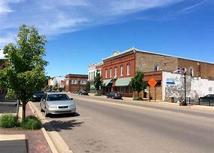
2019 LOCAL CONTENT AND SERVICE REPORT
STORIES OF IMPACT

WNIT continued its highly successful “OUR TOWN” series in 2019 by producing 1 new feature; OUR TOWN: Berrien Springs (aired August 26). As with OUR TOWN: GOSHEN, OUR TOWN: WARSAW – WINONA LAKE, OUR TOWN – ELKHART OUR TOWN: DOWAGIAC, OUR TOWN: MISHAWAKA, OUR TOWN: SOUTH BEND & OUR TOWN: NORTH WEBSTER, OUR TOWN: HARBOR COUNTRY OUR TOWN: NILES, OUR TOWN: BUCHANNAN, OUR TOWN: SYRACUSE OUR TOWN: BENTON HARBOR, OUR TOWN: ST. JOSEPH, OUR TOWN: NAPPANEE and OUR TOWN: CULVER, the town’s residents became volunteer videographers. Armed with their own home camcorders, they created a video scrapbook of the stories that make Berrien Springs special. WNIT’s professional staff utilized these video recordings, along with interviews held by the producers with the volunteer videographers, to edit the stories and produce an hour documentary that reflects the emotional ties of the people who live, love and are passionate about OUR TOWN.

In 2019, Education Counts Michiana, WNIT’s newest, weekly local show, produced and featured over 104 educational programs from 11 counties. 18 school systems, 10 colleges/universities, 15 early childhood learning centers and 17 businesses/civic organizations were actively involved. The show’s average viewership was over 7,500 per week and the Education Counts Michiana web site received over 5,000 page views, 2,100 unique visitors and almost 4 minutes of viewing time per segment each month.

In 2019, WNIT presented two, new “Legends of Michiana” documentaries, “Joe Kernan” and “Pat Moody.” WNIT’s cameras took viewers back into time to experience the lives of 2 of Michiana’s biggest philanthropists and entrepreneurs. Through archival and personal photos, as well as on location tapings, viewers saw the biographical feature of five community leaders who have had a major impact on our community and have left lasting impressions few could ever hope to mirror.

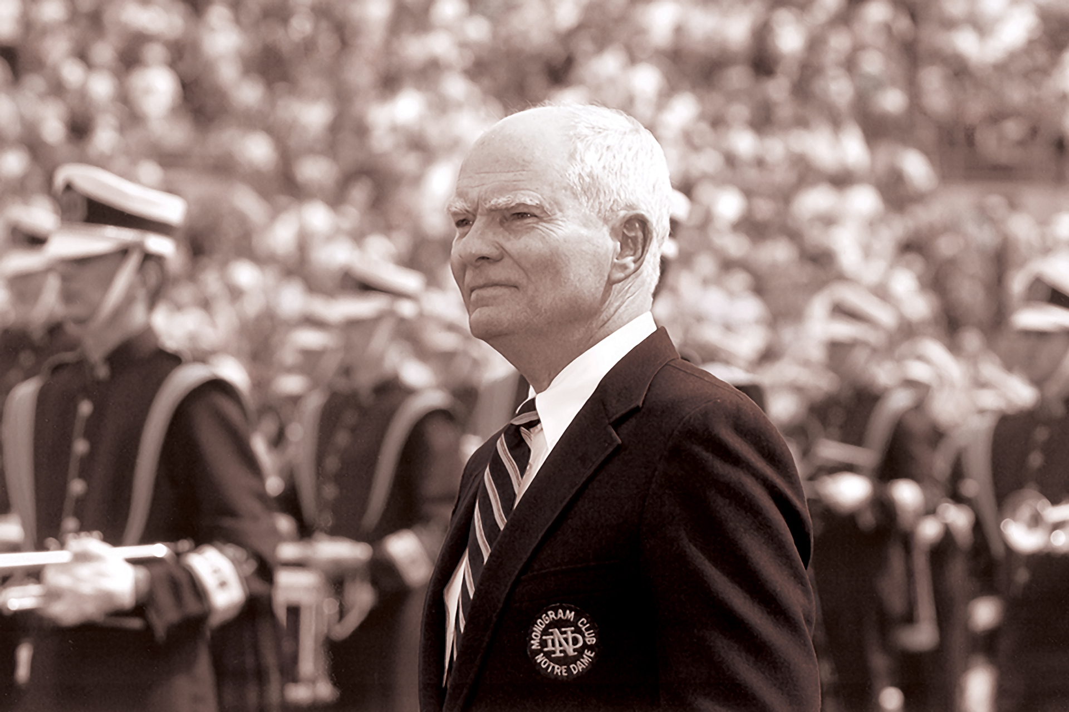

2019 Local Content & Service Report Summary

WNIT is “Michiana’s PBS Station!” Serving 22 counties in northern Indiana and southwest-lower Michigan, WNIT is a trusted, community-owned public media source dedicated to inspire, inform, educate, entertain, and unify the communities we serve. Our vision is to foster enlightenment in our community anytime, every time and everywhere. Our commitment is to not only bring our viewers iconic PBS programs such as Downton Abbey, Sesame Street and Antiques Roadshow on channels 34.1 and 34.2, but also bring our viewers strong local productions like Education Counts Michiana, Dinner & A Book, Outdoor Elements, Experience Michiana, Economic Outlook and Politically Speaking that engage, inspire and most importantly, inform.

At WNIT we keep our viewers in mind because this is their PBS Station and at WNIT….There’s Something for Everyone!

WNIT Broadcast Map
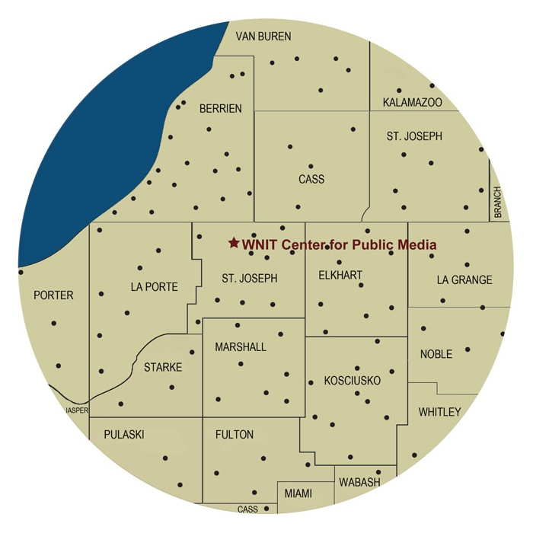

“By watching PBS Kids, children can exercise and develop their brains without the pressures and restrictions of a school assignment. They are asked to explore their own mind and create their own curriculum!” - Ben D.

