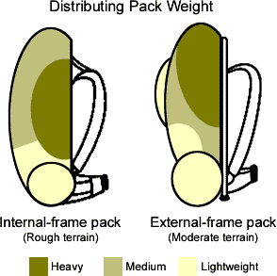
Internal frame pack
(Rough terrain)
External frame pack
(Moderate terrain)
Heavy
Medium
Lightweight
Distributing Pack Weight
(Drawing Courtesy of REI -www.rei.com)

Founded in 1920, Incorporated in 1976

